Assignment 3:

Johannes Mämmelä
15027782
johannes.mammela@tuni.fi

- Introduction:
There are some functional differences between fetus and adult hearts. After birth, the left ventricle pumps blood to body and the right pumps the blood to the lungs for acquiring oxygen. For the fetals, oxygen is supplied by the placenta and both ventricles are pumping blood to the body. For this purpose, there are two shunts, called the foramen ovale and the ductus arteriosus that link the outgoing vessels of both ventricles. This allows blood to go to the right atrium and and bypass the pulmonary circulation. After birth the foramen ovale closes with the first breaths and the ductus arteriosus partially closes in 10 to 15 hours after birth and after three weeks it is completely closed. While mechanical function of the fetus heart differs from an adult heart beat-to-beat electrical activity is rather similar. [1]
While recording fetus’ ECG signal, it is always interrupted by mother’s heart. It is so important to separate baby’s ECG and mother’s ECG from each other so we can monitor the action of baby’s heart and notice if something is wrong. Then doctors are allowed to intervene and improve fetal outcome, decrease miscarriages an minimize unnecessary obtstetric interference.

- Methods
One way to separate fetus’ and mother’s ECGs is adaptive filtering. An adaptive filter is a system with a linear filter that has a transfer function controlled by variable parameters and a means to adjust those parameters according to an optimization algorithm. The closed loop adaptive filter uses feedback in the form of an error signal to refine its transfer function. The sketch of the recording set-up is presented in figure 1.

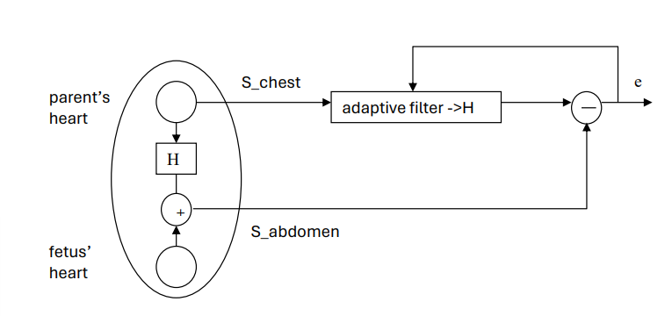
Figure 1: The sketch of recording set-up

In figure 1, S_chest is the measured ECG signal of parent’s chest and S_abdomen is the measured signal from parent’s abdomen. H is the transfer function and e which is the output signal, will approximate the fetus ECG signal. The aim of this exercise is to define the transfer function with starting parameters. The idea is to define good starting parameters N and delta where N is filter order and delta is very small number and create a loop which goes through every integer from filter order to the length of abdomen signal and calculates the error signal between chest and abdomen signals and the transfer function.

- Results

- Conclusion

5. Resources
[1] Reza Sameni, Gari D. Clifford. National Librabry of Medicine. “A Review of Fetal ECG Signal Processing; Issues and Promising Directions” (2010), [Referred 2.5.2024]. https://www.ncbi.nlm.nih.gov/pmc/articles/PMC3100207/

- Matlab codes

